NAPIER UNIVERSITY SCHOOL of COMPUTING

Systems and Services

Unit 8

Processes

Threads

and

Scheduling

Student Study Material

• Alastair Soutar •
• Alastair Soutar • School of Computing • Napier University • Edinburgh •

First published by Napier University, Edinburgh, Scotland © 2008.
No part of this publication may be reproduced, stored in a retrieval system or transmitted in any form or by any means – electronic, electrostatic, magnetic tape, mechanical, photocopying, recording or otherwise – without permission in writing from Napier University, 219 Colinton Road, Edinburgh, EH14 1DJ, Scotland

Overview
This unit builds on the knowledge of processes introduced in the last unit and examines the nature of process states. This then leads in to a study of scheduling algorithms incorporated in modern operating systems..

The concepts of the process descriptor and threads are also introduced.

Learning Outcomes

On completion of this unit you should :

- Understand and further develop the ideas of processes.

- Understand and extend the concept of a process to include threads.

- Understand scheduling algorithms.

Resources Required

Documentation
Course Notes

Project Software

Hardware

Additional Material

Tutorial : Process States

Learning Outcome
On completion of this tutorial you should understand the principles of process states and how this concept is related to the running environment and the scheduling techniques used by operating systems.

Use the unit coursenotes as a reference model when answering the following :

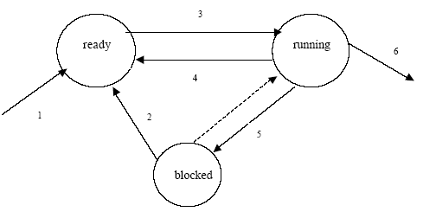

PROCESS STATES

The above diagram shows the states that processes can be in on a typical multi-tasking system.

a) For each of the six numbered transitions, give an example of events that would cause the transition.

b) Some systems allow pre-emption to occur. An example of this is shown by the dotted arrow.

i. Give an advantage that allowing for this to happen would provide

ii. Explain what would happen to the task that was running when this occurred (i.e., determine the state to which it would move)

iii. This implies some prioritisation of processes.
Describe why this would be useful.

c) The discussion so far has been limited to systems with a single processor. Increasingly, systems are using more than one processor. Alternatively, a single processor chip may have so much parallelism built in that it can run more than one process at a time.

Describe how this will change the process state diagram.
Explain the way in which the scheduling algorithms will be affected.

Scheduling Algorithms

1. Five processes which had arrived in a single processor system in the order shown below become ready for CPU bursts together at time zero:

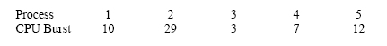

For each of the scheduling algorithms:

(i) First come first served
(ii) Shortest job first
(iii) Round Robin with quantum=10

(a) Draw the Gantt chart to represent the processing by the CPU,
(b) Calculate the average turnaround time for the processes,
(c) Calculate the average waiting time for the processes.

2. Four processes become 'run-able' together with requirements for CPU-bursts as follows:

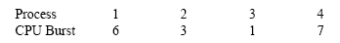

Calculate the average turnaround time using a Round Robin algorithm with time quanta of 1..7.

Practical :

There is no practical associated with this module. However, the structures tutorial from the Linux
unit should be used to familiarise the reader with tasks.

Processes, Threads and Scheduling

Processes and Process States

It should be obvious that the processor is severely limited as it can only run one process at any given time. Thus, whether a process is ‘active’ or not at any point is described by its process state.

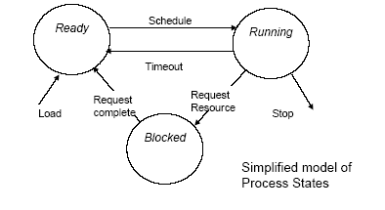

From the diagram, the possible states of the process are:
. Ready-to-Run
A process in this state is not actually running, but could be run if it were assigned to the processor - i.e. if a processor were available. There could be several processes in this state at any time.
. Running
The CPU registers hold values from this process and the current instruction sequence comes from this process. There is only one process in this state in a single processor system.
. Blocked
A process in this state could not run even if the processor were free. The process is usually waiting for some “slow” device to provide input or accept output - e.g. a process that is waiting for a user to enter data will be “blocked” until the user types in the data. There could be several processes in this state at any time.

The Process Descriptor

The “process status area” shown in the memory map of a process image is sometimes called the “process descriptor”.
It may exist as part of the process, as shown in the diagram on Page 4. In this case the descriptors (status areas) of the current processes are “chained” together to form a list of processes. The scheduler uses this list to decide which process to run next

Alternatively, it may exist as a table of entries held within the operating system. In this case, the descriptor (table entry) for each process contains pointers to the other parts of the process.

Each descriptor therefore describes one process and is a record of that process. When a process is created, its status area is linked to the chain, or a table entry is created (depending on the approach taken). When the process terminates the entry is removed from the chain or the table.

The table entry below shows the contents of a typical process descriptor as it might appear in the process status area. In a table form, this would also include pointers to the other parts of the process in memory.
For example, the “process status” would show “running”, “ready” or “blocked”.

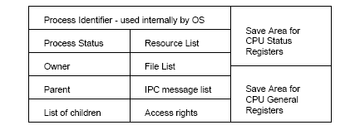

This table, or chain, is “visible” to most Operating System processes, e.g.:

If a file is opened, its identifier is added to the File List.
Before opening the file the OS will check the process’s access rights

The scheduler uses this table to decide which process to run next,
Messages from other processes can be placed in the IPC (inter-process communication) List. As only one process is running at any time this is how processes communicate with each other.
The size of the table, or length of the chain, is preset to the maximum number of processes that can be accommodated. In practice, the actual number of processes may be smaller because of resource constraints.
As processes are closed down, the table or chain entries are re-used for new processes.

A special purpose Operating System may have a fixed set of processes - e.g. an industrial controller.

Threads

A process has a defined memory space accessible only to that process. However, when the scheduler is active, physically switching the CPU from one process to another takes a relatively long time, as it involves the following actions.
First, copy the contents of all CPU registers to the save area, and choose the next process.
Then load the CPU registers with the values from the save area of that process.

An alternative approach is to use “threads” or “threaded processes as shown:

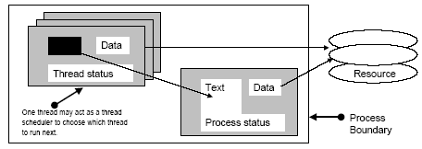

The process is divided into several mini-processes or “threads.” Each thread

. contains a stack, some status information and some OS table details.
. can share the Text, data and resources of the main process.

The main scheduler selects the process as before. Within that process a “thread scheduler” allocates the available timeslice between the threads.
Switching between threads involves only saving the thread status because the
same process is still “running”. If none of the threads can make progress (or the main scheduler interrupts) the process will stop being the running process.
For example, Netscape or Internet Explorer can load several parts of a page “simultaneously” (- Look at the BBC News website)

One issue with this scheme is whether the “thread scheduler” should be part of the kernel (the ideal solution) or part of the process (often as an extra thread).

The Low-level Scheduler

This is a process which is invoked when a “new” process is to be allocated to the processor. This usually happens when the running process blocks or terminates, but it may be after a sequence of tasks (as in batch systems).
The choice of process is made using a scheduling algorithm. Several algorithms are available: each selects a process from those in the
“ready-to-run” queue and nominates it as the “running” process. Examples are, FCFS - (first come first served); SJF - (shortest job first) - based on an estimate of how long the process is likely to run before it terminates, or before the next blocking event; Round Robin - each process is allowed to run for a maximum timeslice (called the quantum) then put back into the ready-to-run queue. It may block or terminate before the end of the timeslice; and Priority - some property of each process is used to define its importance - the most “important” process is run next.

Definitions:

“Turnaround time” is the time elapsed from the process first entering the ready-to-run queue until it terminates.

“Waiting time” is the time a process spends in queues (either blocked or ready-to-run).

“CPU-burst” is any time period when a process is the running process.

Scheduling algorithms

Each algorithm has different characteristics with respect to turnaround time and waiting time, for a given set of CPU-bursts.

A major problem in deciding which algorithm to use in a system is the fact that the actual pattern of CPU-bursts is indeterminate. Thus, the algorithm that is best for one task mix may be less optimal for another.

FCFS is a simple algorithm and is used for batch systems. However, short tasks can be delayed by long tasks.
SJF favours short tasks, giving better average turnaround and waiting times.
RR gives the best response times for interactive tasks (This implies processes having short CPU bursts and longer periods blocked, waiting for I/O).

The performance of a system as perceived by the user depends on many
factors, including user expectations.
Two common measures are:
. Mean turnaround time: average time in the system.
. Mean waiting time: average time spent ready-to-run or blocked.

Consider a system with 3 processes in the “ready-to-run” state:
The scheduler is about to select one to become the “running” process; each process is expected to use different amounts of CPU time as follows:

Process A -will require 6 units.
Process B -will require 4 units.
Process C - will require 2 units.

The following diagrams show the behaviour of the system with different algorithms (sometimes called scheduling policies).

FCFS - First Come First Served

The processes are placed in the ready-to-run queue in the order of arrival:
The first process becomes the running process (say, A then B then C).
There is no priority: short or important processes may have to wait for long unimportant processes to release the CPU.
However, this policy is simple to implement.

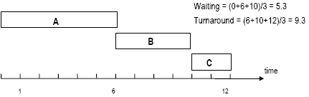

SJF - Shortest job first

The processes are taken from the queue in the order of their estimated CPU-burst time. The “shortest” process becomes the running process (in this case, C then B then A). In effect, priority is given to “short” tasks.
However, as estimates of CPU-burst time are difficult to make accurately, then results may not be as predictable in practice as in the theory.

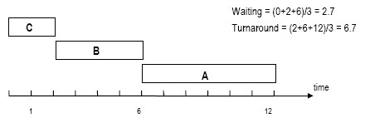

RR(q=n) - Round Robin (quantum=n)

The processes are taken from the queue in some order (let’s assume FCFS). The process is allowed to run for a maximum time (e.g. the quantum 20mS.If the task does not finish within the quantum, it is returned to the queue.
This is a good algorithm for multi-user interactive systems. The length of quantum chosen affects performance.

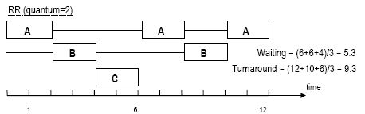

Priority scheduling

Some feature of the process is used to specify importance, or priority. In fact, SJF is a “priority” algorithm based on predicted CPU-burst. Other features chosen could be resource demand, or simply a value assigned to the process by the operating system. Or, priority can be related to the “user” who owns the process, to money (pay more and get higher priority), or any value set by the system manager.

The scheduler selects the process with the highest priority from the ready-to-run queue and makes it the running process. A process may be passed over many times (there may always be another process or processes with a “higher” priority.
To overcome this, some algorithms raise the priority of a process every time it is passed over so that eventually, it must become the highest priority process. This technique is called “ageing”.

Other scheduling issues

Some systems have several queues of processes. Each queue may have its own algorithm. For example, a system might have:

An “interactive” stream using RR with a priority queue (foreground) and,
a “background” stream using an FCFS queue.

There may be an algorithm to select between the queues, for example, run an interactive job if there are any, otherwise run a background job.

The examples illustrated are a bit simplistic and it should be remembered that real queues are dynamic. In other words, new processes enter the queue, processes terminate unexpectedly, and blocked processes rejoin the queue.

Also, the queue may change radically between any two scheduling events (i.e. any two runs of the scheduler).

Pre-emptive scheduling means that a process might not be allowed to continue to the end of its time-slice. The running process may be swapped-out prematurely (or pre-emptively) by the scheduler to allow the system to deal with some other process (e.g. interrupts).

End of Unit - Summary of Achievements

On completion of this unit you should have achieved the following :

On completion of this unit you should understand :

- Understand and further develop the ideas of processes.

- Understand and extend the concept of a process to include threads.

- Understand scheduling algorithms.

